Login/Register on CITI Program Website

Go to CITI Program's Website Homepage https://about.citiprogram.org/en/homepage/
For prior users, please login using the login button on the upper right portion of the home page. If you have a CITI Program username and password: Log in with your existing CITI Program username and password. If you have forgotten your username or password you can retrieve them through the "Forgot" links in either the username or password boxes.

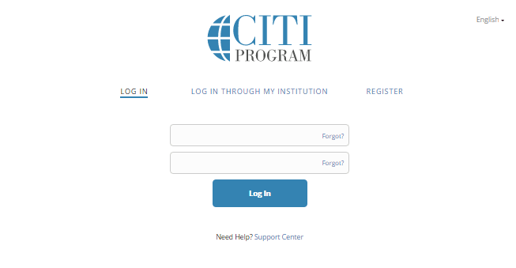

New Learner Registration Instructions: For new users, you must REGISTER. Registration using the Register button on the upper right portion of the home page. The next steps are numbered 1-7. These steps will collect information to register your account and place you in the correct course based on settings for The Sage Colleges.
Step One
Click on "Select Your Organization Affiliation" This option is for persons affiliated with a CITI Program Subscriber Organization. Enter “The Sage Colleges” and click on the link to go to your organization's log in page.
Click the link to “agree to terms of service and privacy policy.” There are links to these materials if you are interested.
Click “I affirm that I am an affiliate of The Sage Colleges”
Click the blue button “continue to create your CITI program username/password” After you log in, you will be redirected to the CITI Program website.

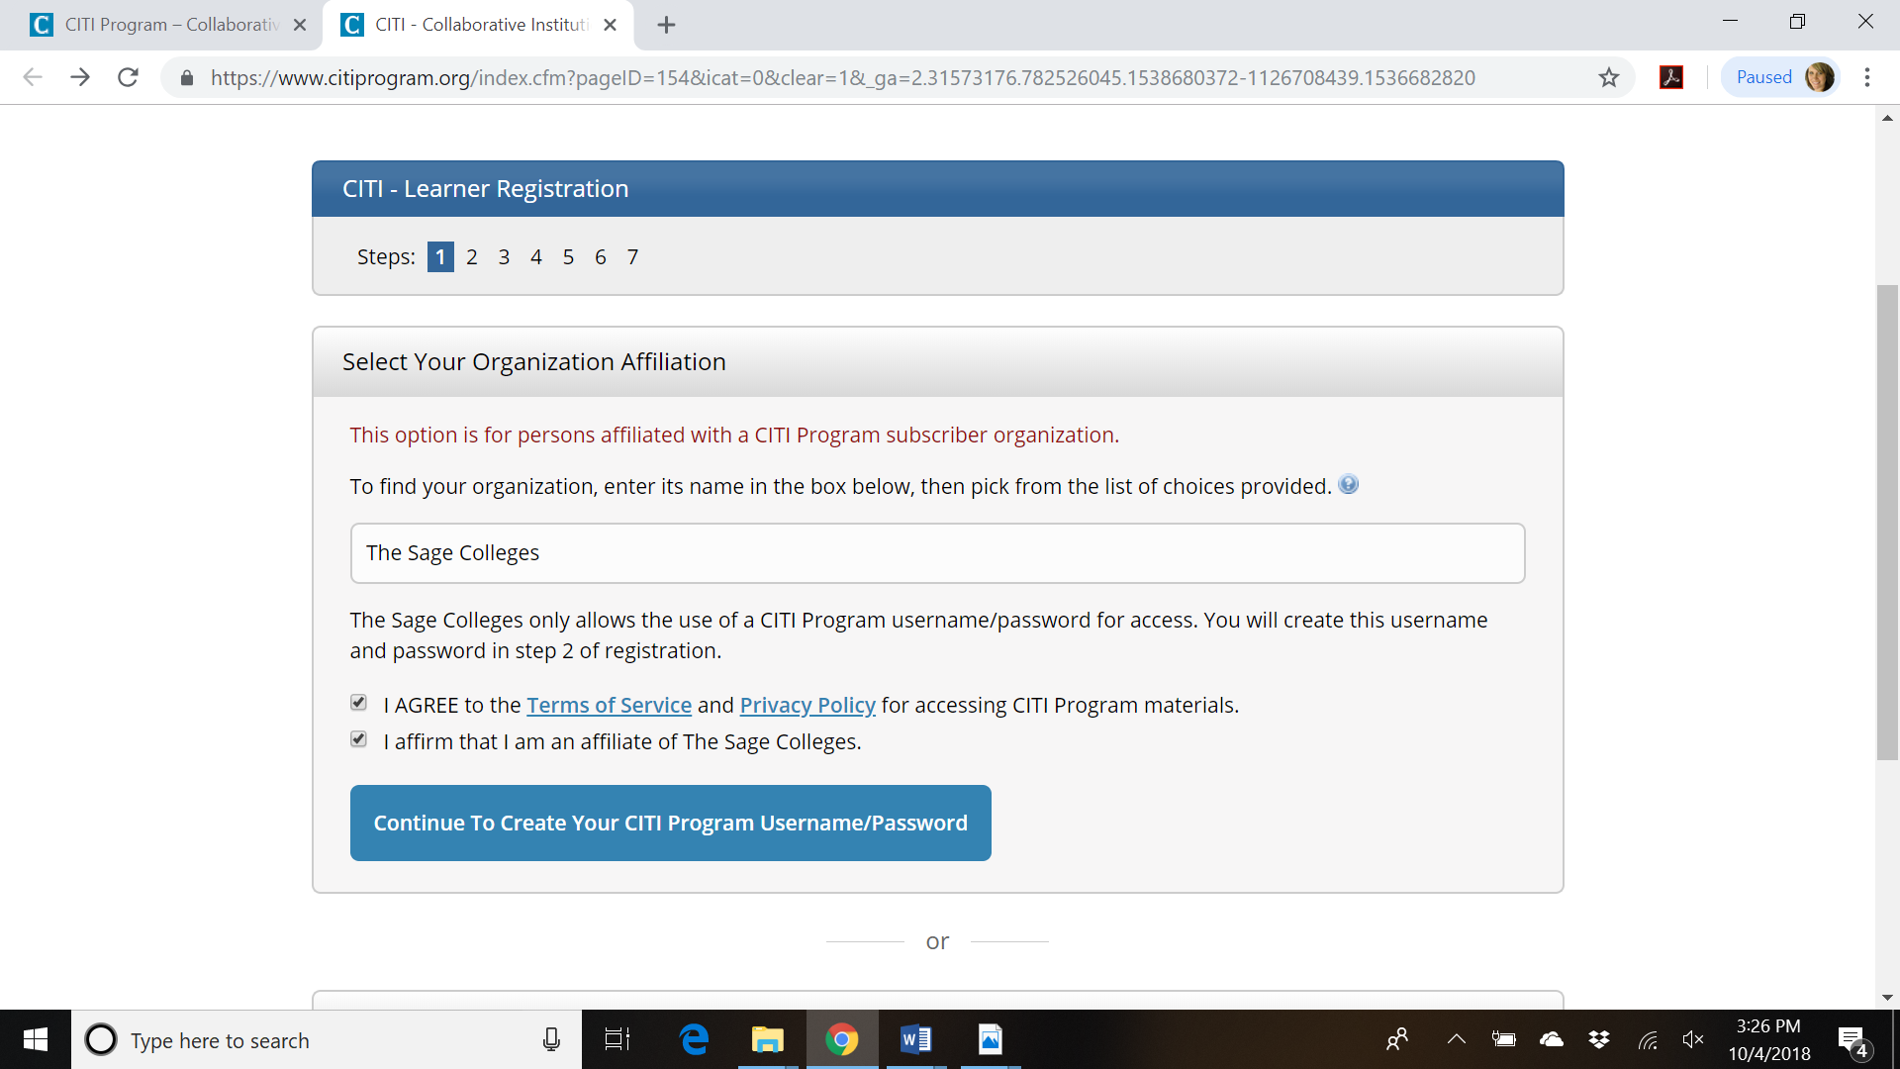
Step 2 requests that you enter your first and last name along with your email address. Please enter your name here as you would like it to appear on your completion report received at the end of the course.
You can use any email address to register but we recommend not using your organizational email. The account belongs to you, the learner, and if you leave the institution you will still have access to the account if you use a non-organizational email. This means you can keep the same account and transfer credit if you affiliate with a new organization.
While not required, we do encourage entering a secondary email address. It will assist in the recovery of your account if you forget your username or password and no longer have access to your primary email address. You can use your institutional email for this.
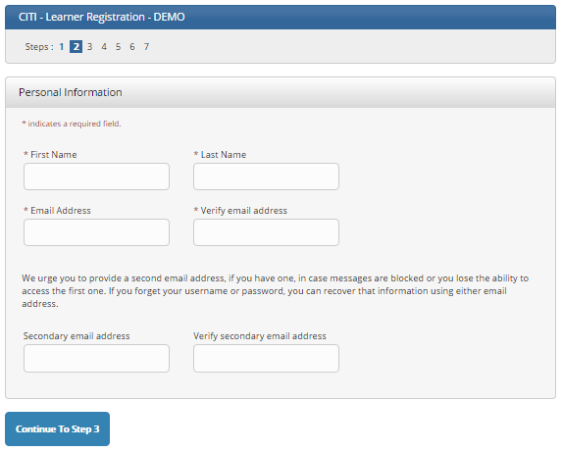
At Step 3 you will choose a username and password for your account. Please follow the on-screen instructions for the expected parameters of each field. Passwords are case sensitive.
During this step you will also select and answer a security question. This question will be used to assist in the recovery of your account if you have forgotten your username or password. Please select a question that is applicable to you and which you can comfortably answer for the tech support team.
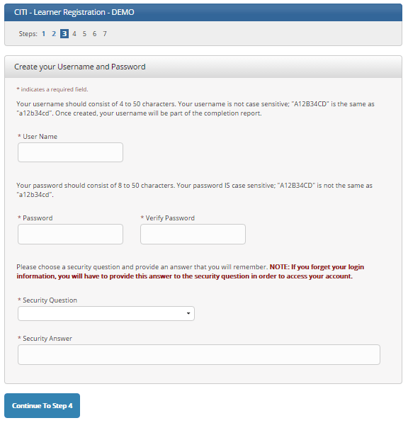
Step 4 asks for your country of residence.
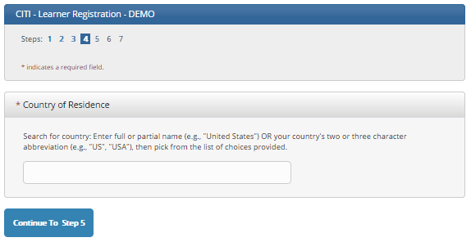
Step 5: Professionals seeking credit for CITI Program courses can make their selection for Continuing Education (CE) credits. The Sage Colleges does not offer CE Credits through our organization. All costs associated with these credits will be the responsibility of the researcher. Please click “no” if you are not interested in CE credits.
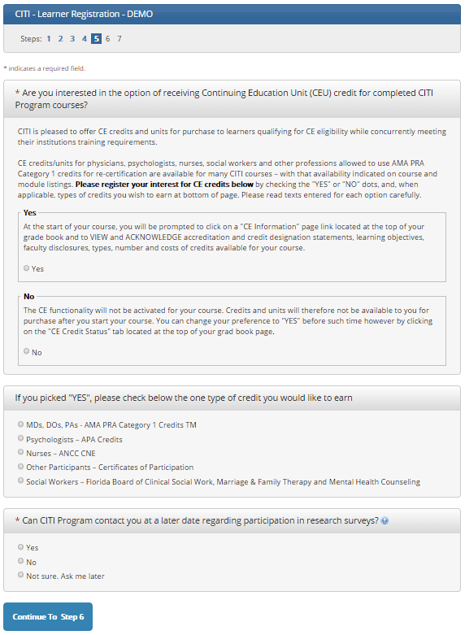
This step is where you can also let CITI Program know your interest in participating in research surveys at a later date.
Step 6 is The Sage Colleges specific. Employee ID and/or student ID is optional. Any questions regarding the fields on this page should be directed to The Sage College’s CITI Program administrator, Francesca Durand at sageirb@sage.edu.
For the Role in Research Question- you are either:
- PPI- Faculty
- CO-I (Co-Investigator)- Students
For Address- You can use your school address or home address.
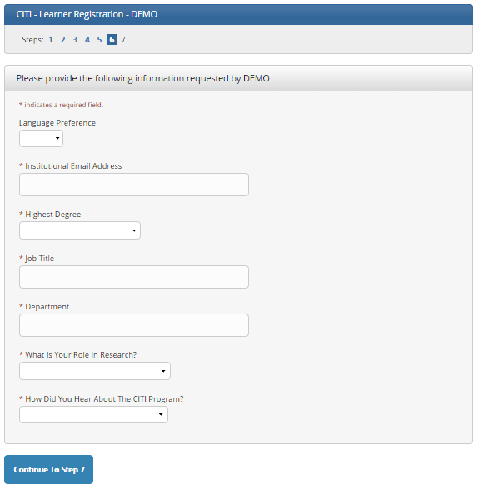
The questions in Step 7 enroll you in CITI Program courses. These questions are set up based on the organization specific courses. Please read each question carefully to ensure you are enrolled in the correct course.
For The Sage Colleges IRB purposes, you need to take and pass the Human Subjects Research (HSR) course only. There are other courses that your instructors/professors might require that you take. You can access those at any time by logging back in to the CITI Program web
After selecting your courses, click on Finalize Registration.
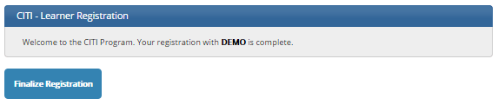
Your learner account registration is complete.
You will now be able to access the Main Menu of your account.
Click on the course name to begin the course. If you need to change your course registration, click on Add a Course or Update Learner Group.
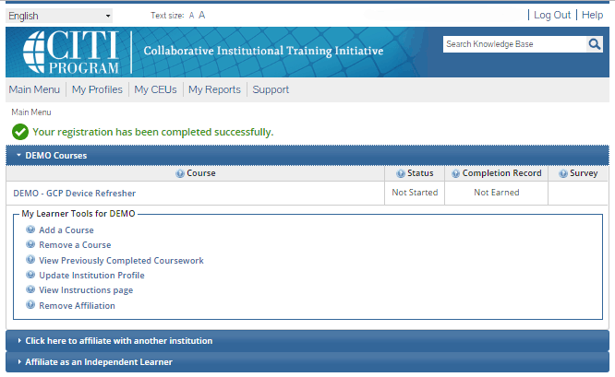
For further assistance, you may want to see our Guide to CITI Navigation.
Who do I contact for technical support?
For technical support related to the CITI program, you can call our support center at 888.529.5929 or e-mail us at support@citiprogram.org.
Our support desk is open from 8:30 a.m. to 7:30 p.m. U.S. Eastern Time (EST/EDT) Monday through Friday. We are closed on all U.S. Federal Holidays.

