Guide to CITI Navigation

Main Menu
When you first log into your account, the first thing you would see is the Main Menu. Please take note of your name and CITI Member ID number in the top right corner. This will be present on all CITI Program pages if you are logged in your account.
From here, you can view your active Courses, Learner Tools, and update your affiliations.
Courses: To begin a course, click on the title of it. Your current status can be viewed at a glance from the Main Menu. Once you have completed the course, you may also access the Completion Report for it from here.
My Learner Tools
- Add a Course or Update Learner Groups: If you need to update your enrollment, you may do so here.
- View Previously Completed Coursework: View your past completions, expirations, and access completion reports.
- Update Institution Profile: Update your contact information, institutional identifiers (email/IDs), role in research, or other institution-specific information
- View Instructions page: Your institution may provide contact information or guidance here if you are unsure of your requirements or need assistance accessing a course.
- Remove Affiliation: Remove this institution from your profile. You will no longer have access to courses under the institution unless you re-affiliate.
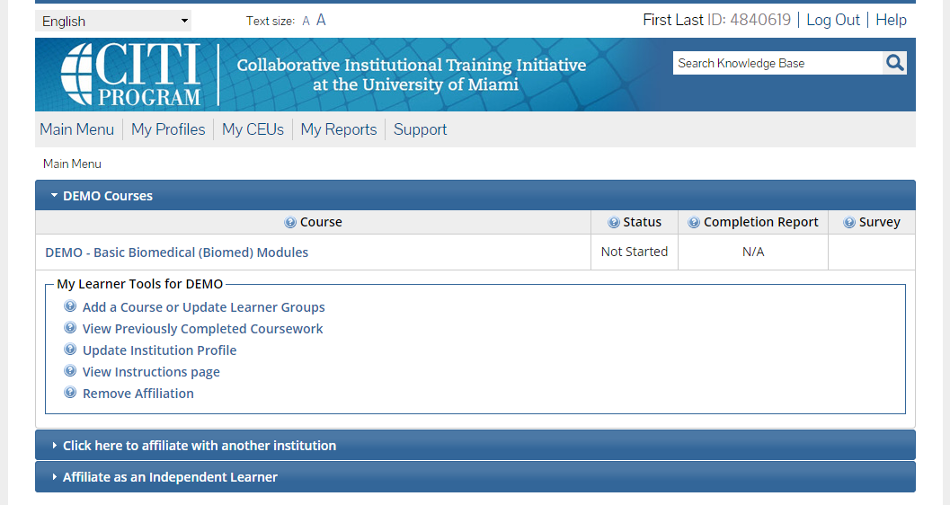

My Profiles
CITI Program Profile: You may change your name, update your email address, manage CE credit preferences, and update your security question and other personal information.
Institution Profiles: Below the CITI Program Profile, a Profile will be listed for each institution you are affiliated with. You may update your contact information, institutional identifiers (email/IDs), role in research, or other institution-specific information
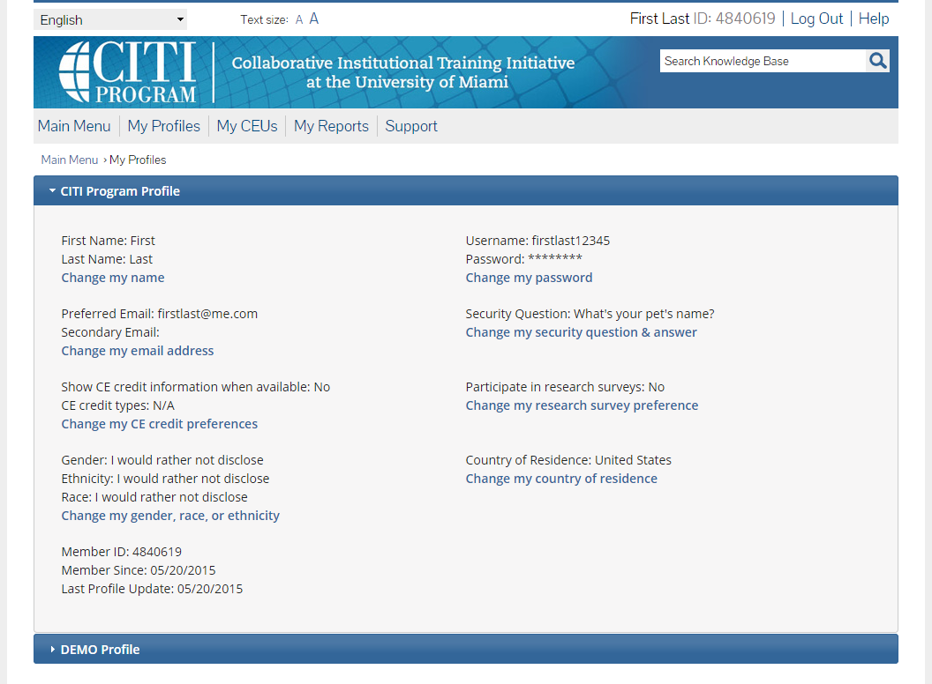

My Reports
Access completion reports, view expiration dates, scores and other information for all your current and past affiliations.
Completion Report: Once you have completed a course, a View link in the Completion Report column will appear. From here you may access the completion report. Completion reports are downloaded in PDF format, so please ensure you have the latest version of Adobe Reader or a similar PDF-viewing application installed.
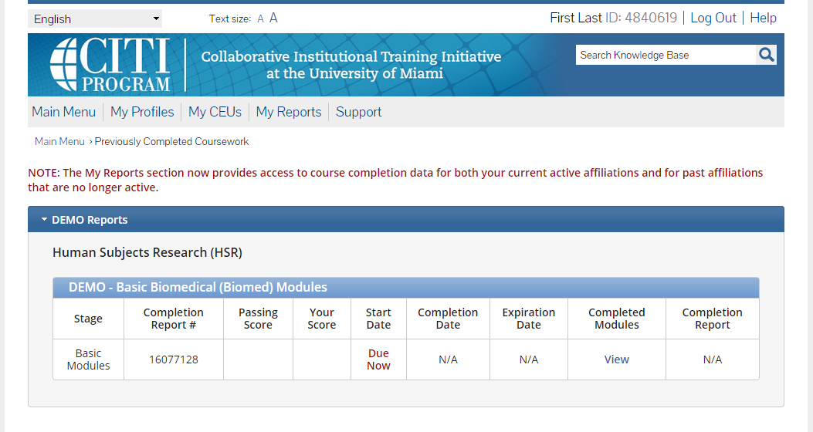
Last Updated: 12-Mar-2017 9:16 p.m. EDT

Who do I contact for technical support?
For technical support related to the CITI program, you can call our support center at 888.529.5929 or e-mail us at support@citiprogram.org.
Our support desk is open from 8:30 a.m. to 7:30 p.m. U.S. Eastern Time (EST/EDT) Monday through Friday. We are closed on all U.S. Federal Holidays.

